369ai
H R S U I T E F O R O D O O 1 9

EMPLOYEE DEVICE

HR Step-by-Step Guide

Authorize one phone per employee with a Device ID and PIN, and block lost or replaced phones without losing the record.

A simple guide to authorizing an employee's phone for attendance by registering their Device ID and PIN, keeping one device per employee, and blocking lost or old phones without losing the record.

Module Version 19.0.1.0.0 · Odoo 19 · Human Resources

About Employee Device Management
The Employee Attendance app only accepts a check-in or check-out from a phone that HR has registered for that employee. Each employee has one device on file, identified by a 10-digit Device ID and protected by a PIN. As long as that device is Active, the employee can mark attendance from it; turn Active off to block a lost or replaced phone without deleting its history.
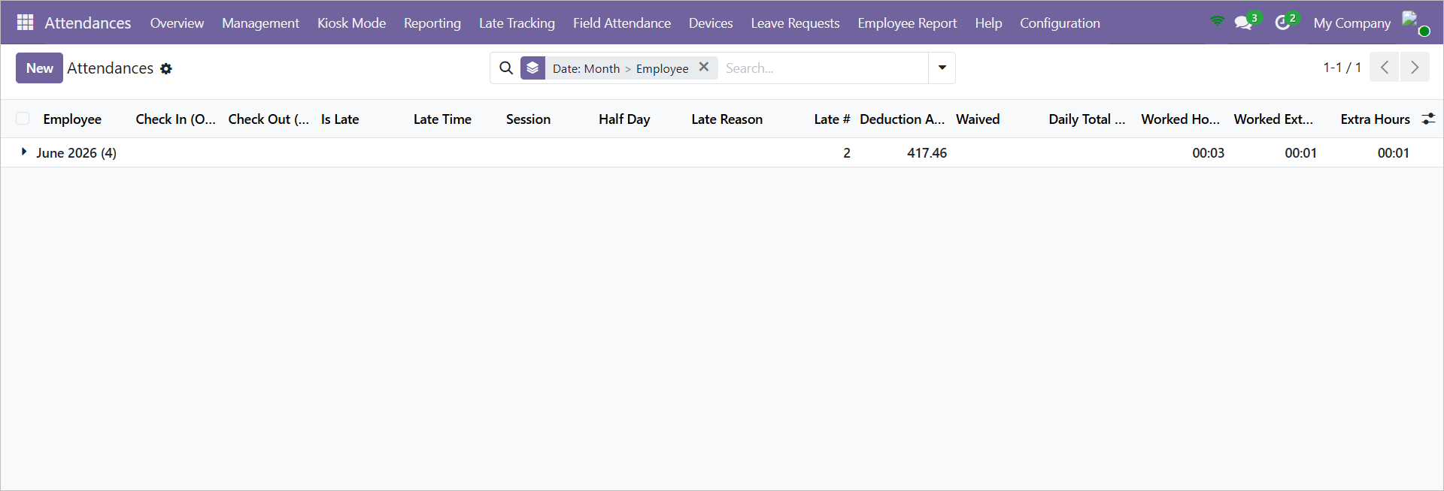
The Employee Attendance app — open the Devices menu from the top bar.

How Device Registration Works
- Ask the employee for their 10-digit Device ID.
- Open the employee from the Attendances → Devices menu (this is the only place devices are added or edited).
- Enter the Device ID and set a PIN.
- Make sure the device is Active, and save.
- Device Name and Last Used fill in automatically once the device is in use.
PART 1 Opening Device Registration
Step 1 Open the Devices list
In the Attendances app, open the Devices menu in the top bar (next to Late Tracking and Field Attendance). You'll see a read-only list with one row per employee, showing Name, Device ID, Device Name, Active, Device Added On, and Last Used.
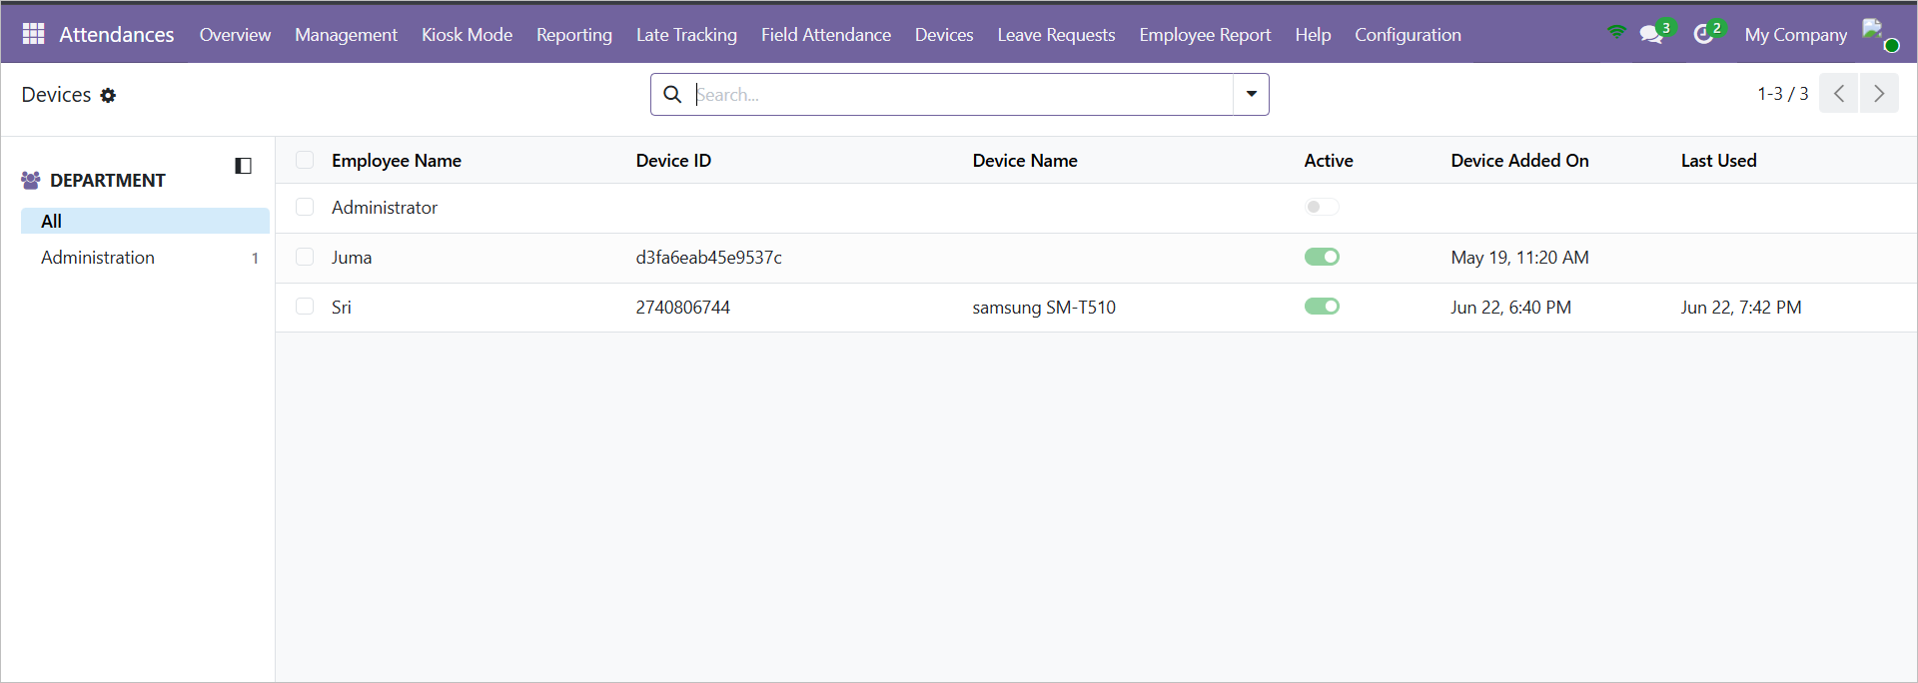
The Devices list: one read-only row per employee.
Step 2 Open the employee's device form
Click any row to open that employee's device registration form, where you set the Device ID and PIN. The employee's own Devices tab (on their profile) shows the same details but is view-only — devices are added or edited only from the Attendances → Devices menu.
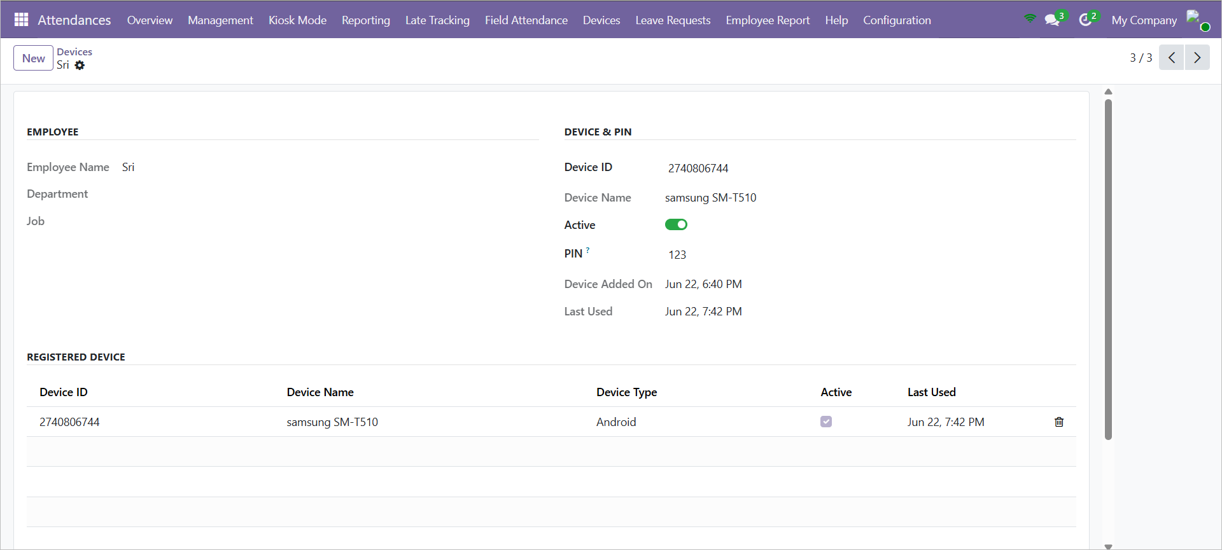
The device registration form, opened by clicking an employee row.
PART 2 Registering the Device & PIN
Step 3 Get the Device ID
The employee has a 10-digit Device ID for their registered device. Ask the employee to provide it so you can enter it in the next step.
Step 4 Enter the Device ID
In the Device ID field, type the 10-digit code exactly as provided by the employee.
Step 5 Set a PIN
Under PIN Authentication, set a PIN for the employee. This PIN verifies the employee when marking attendance.
Step 6 Confirm Active and save
Make sure Active is switched on, then save. Attendance can be marked only from a registered and Active device.
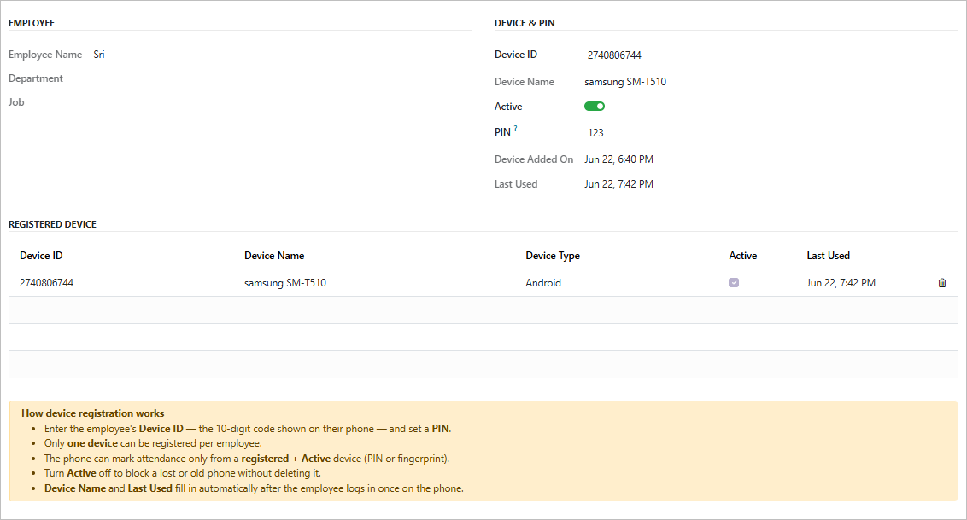
The Device & PIN panel — Device ID, PIN, and Active — with the built-in guidance.
Step 7 Let auto-fill complete
Set the Device Type (Android or iOS) if you wish. Device Name and Last Used are filled in automatically once the device is used — you don't need to type them.
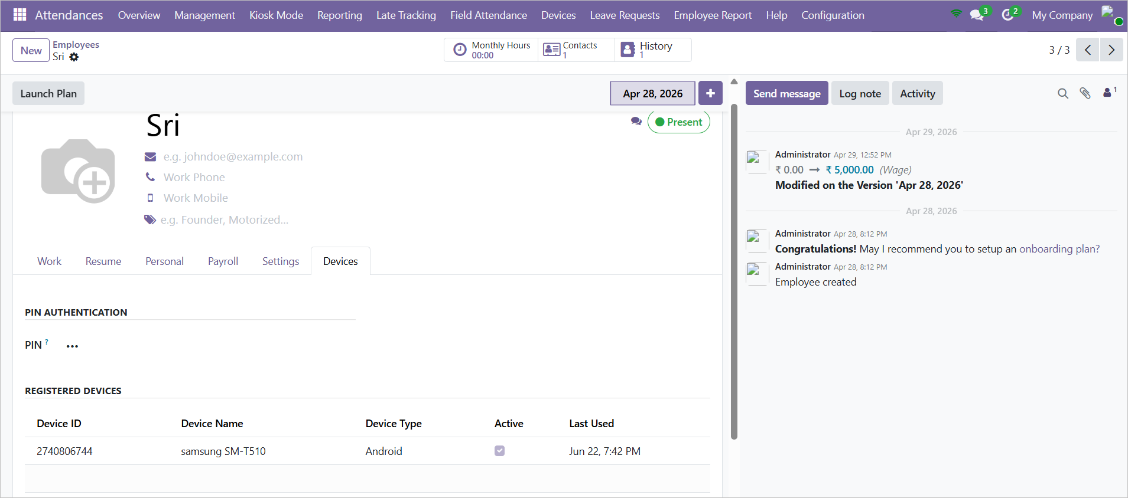
The employee profile Devices tab: Device Name and Last Used fill in automatically.
PART 3 Managing Devices
Step 8 Block a lost or old phone
To stop a phone from marking attendance, turn Active off instead of deleting the device. The record (and its history) stays, and you can switch it back on later.
Step 9 Replace a device
Each employee can have only one device. To move an employee to a new phone, update the existing Device ID (or deactivate it first) — adding a second device is blocked.
Step 10 Check recent activity
Use the Last Used column or field to confirm a phone is active and being used to mark attendance.

Reference: Device Fields
Field | What it means
Device ID | The 10-digit code that identifies the employee's authorized device.
Device Name | The device's name. Fills in automatically once the device is in use.
Device Type | Android or iOS. Defaults to Android.
Active | Whether the device may mark attendance. Turn off to block without deleting.
PIN | The code that verifies the employee when marking attendance.
Device Added On | When the device record was created.
Last Used | When the device last marked attendance. Fills in automatically.

Things to Remember
IMPORTANT Only one device can be registered per employee. Remove or deactivate the existing device before adding a new one.
IMPORTANT Attendance can be marked only from a registered AND Active device, verified by PIN.
TIP Lost or replaced a phone? Turn Active off rather than deleting — you keep the history and can re-enable it if the phone comes back.
— End of Guide —

